SCREEN DESIGN

LOGIN PAGE:

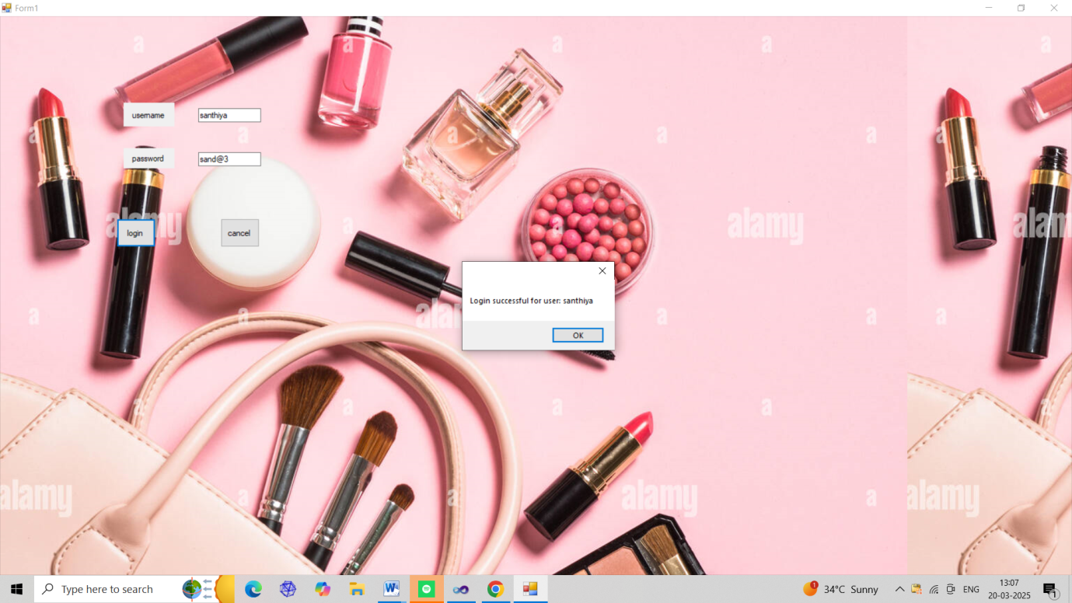

FIGURE 1

NAVIGATOR PAGE:



FIGURE 2

PRODUCT DETAILS:

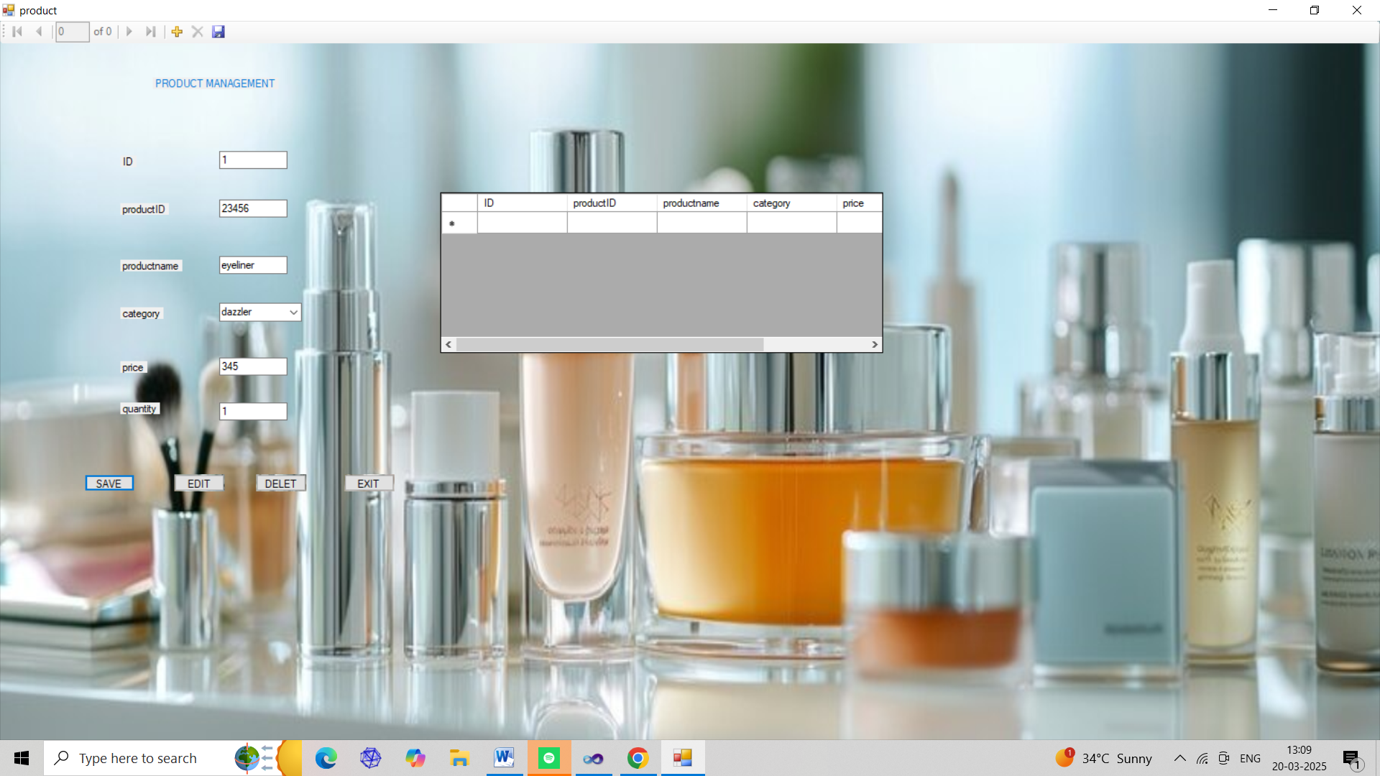

FIGURE 3

CUSTOMER DETAILS: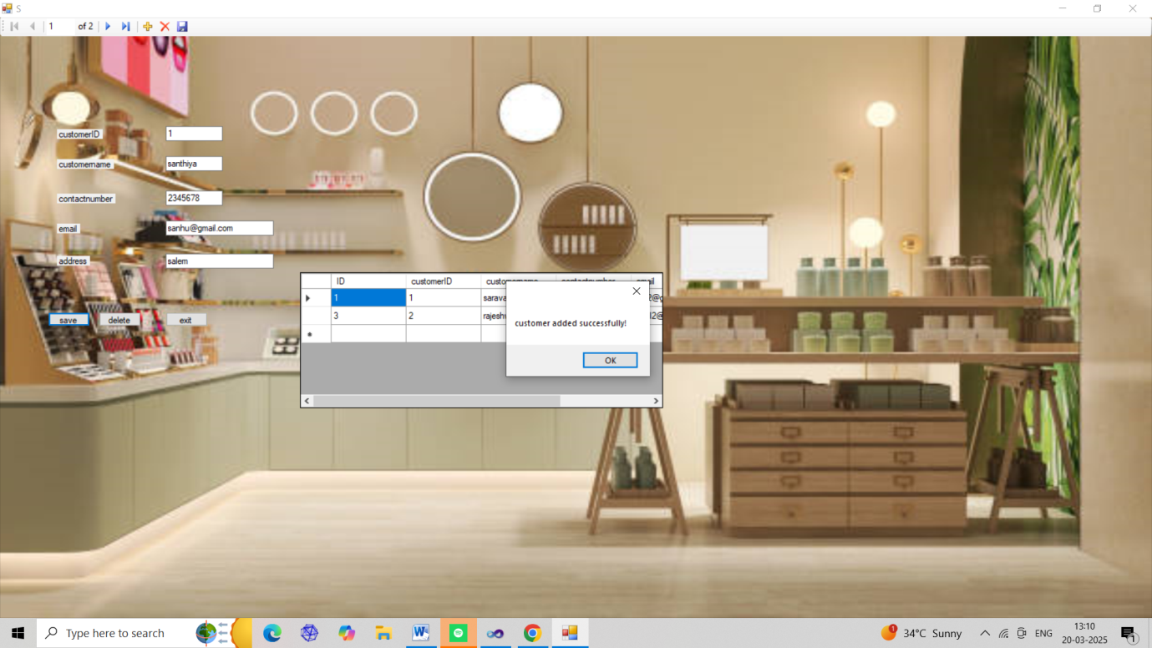

FIGURE 4

EMPLOYEE DETAILS: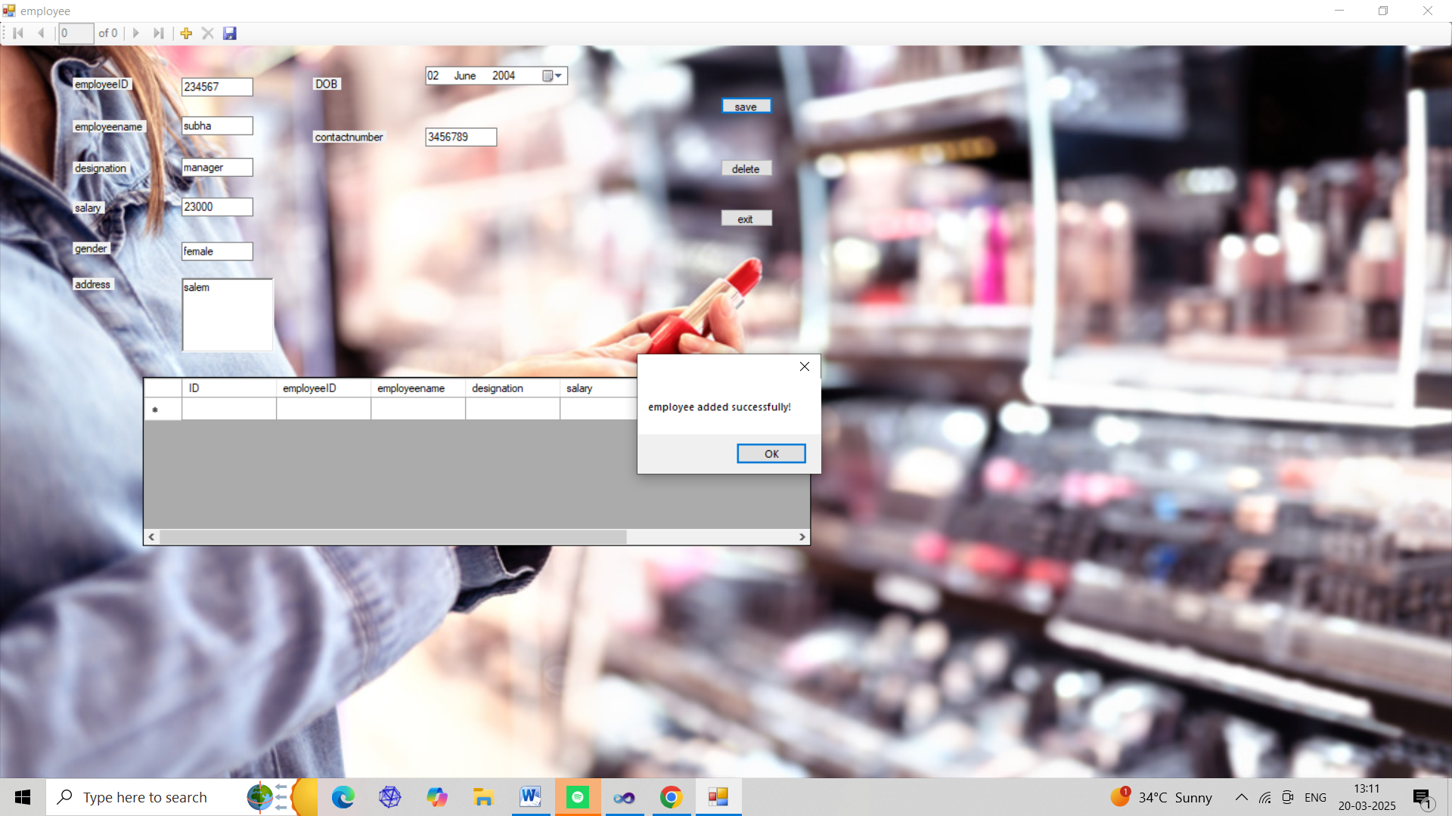

FIGURE 5

SUPPLIER FORM: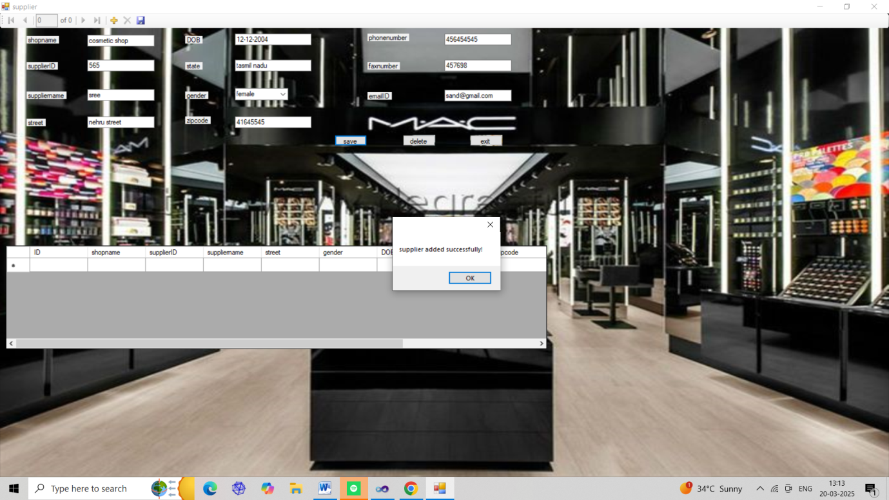FIGURE 6

CUSTOMER DETAILS REPORT:

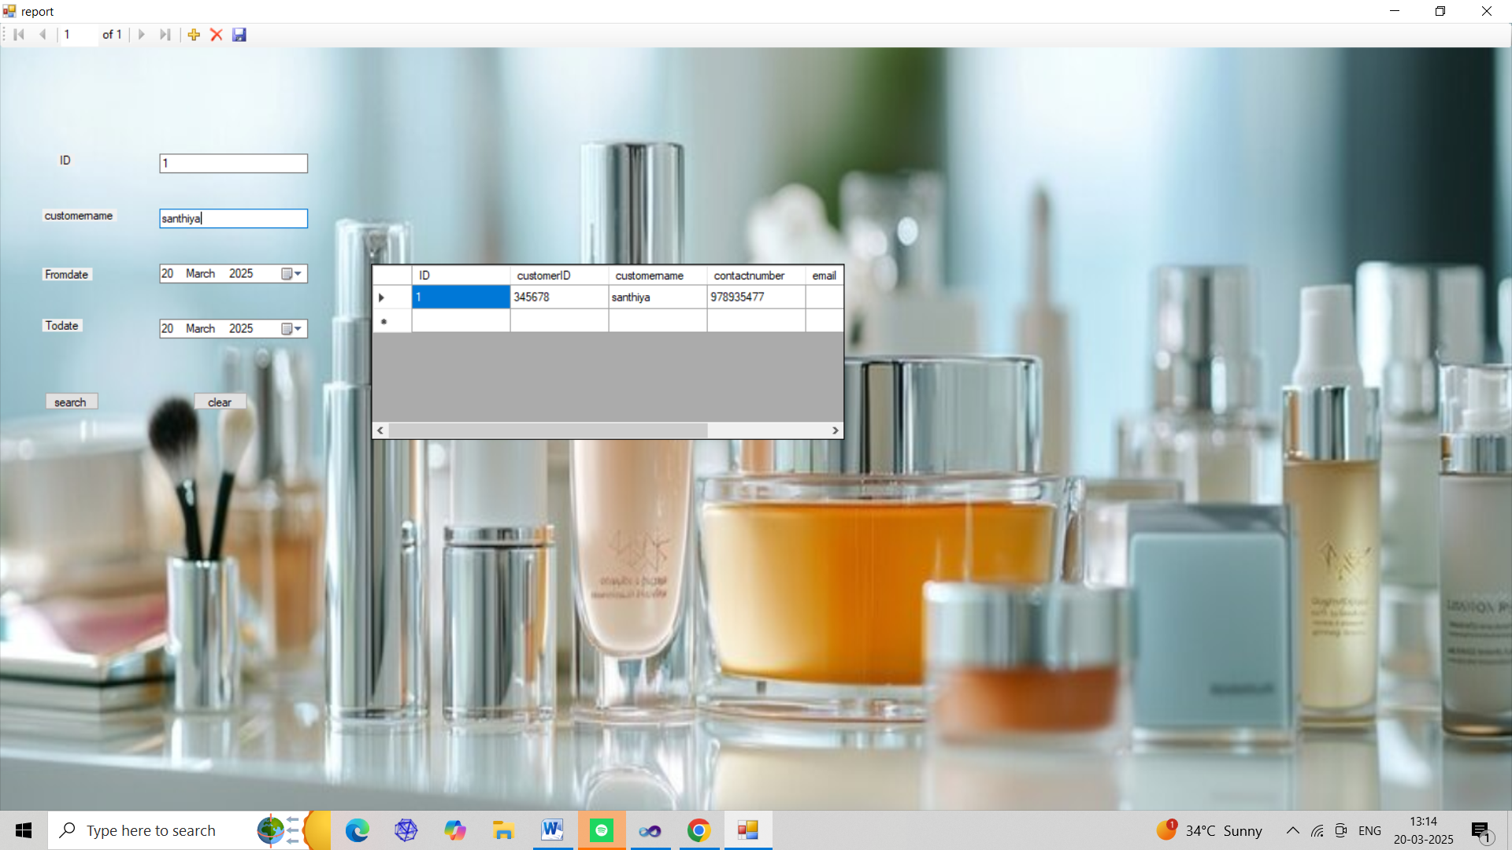

FIGURE 7